|  |  |
| --- | --- |
| Git | Git is an open-source distributed version control system. It is designed to handle minor to major projects with high speed and efficiency. It is developed to co-ordinate the work among the developers. The version control allows us to track and work together with our team members at the same workspace. |
| How to download Git? | 1. Goto <https://git-scm.com/downloads>.  2. Select the OS and Bit of OS Version of Git.  3. Install the setup file. |

**GIT Repository**

Repositories in GIT contain a collection of files of various different versions of a Project. These files are imported from the repository into the local server of the user for further updations and modifications in the content of the file. A VCS or the Version Control System is used to create these versions and store them in a specific place termed as a repository.

**Types of Git Repositories:**

**Local Repository:**Git allows the users to perform work on a project from all over the world because of its Distributive feature. This can be done by cloning the content from the Central repository stored in the GitHub on the user’s local machine. This local copy is used to perform operations and test them on the local machine before adding them to the central repository.

**Remote Repository:**Git allows the users to sync their copy of the local repository to other repositories present over the internet. This can be done to avoid performing a similar operation by multiple developers. Each repository in Git can be addressed by a shortcut called **remote**.

Git provides tools to perform work on these repositories according to the needs of the user. This workflow of performing modifications to a Repository is referred to as the **Working Tree**.

**Working with Git:**

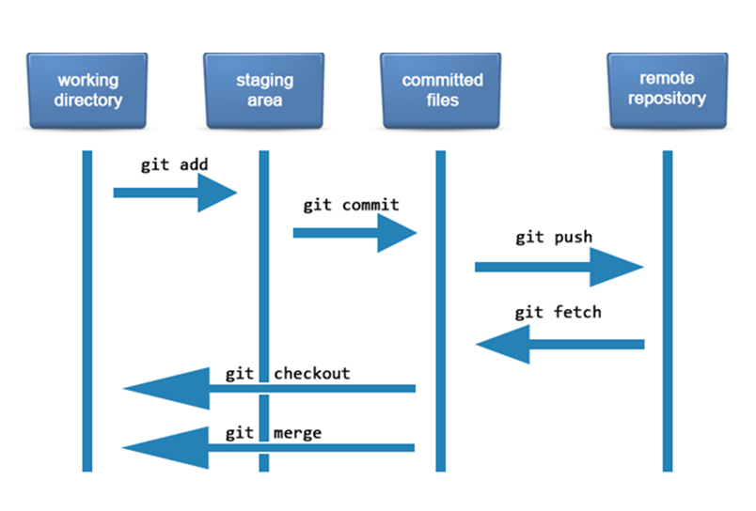

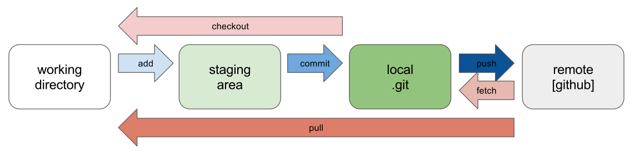

|  |  |  |
| --- | --- | --- |
| **S.No.** | **Git** | **GitHub** |
| **Software/ Service** | Software. | Service. |
| **CLI / GUI** | command-line tool | graphical user interface |
| **Installed / Hosted** | installed locally on the system | hosted on the web |
| **Maintained By** | Linux. | Microsoft. |
| **Focus On** | Version control and code sharing. | Centralized source code hosting. |
| **Purpose** | Version control system to manage source code history. | GitHub is a hosting service for Git repositories. |
| **Launched** | 2005. | 2008. |
| **User Management Feature** | No | yes |
| **Licensed** | open-source | GitHub includes a free-tier and pay-for-use tier. |
| **Tool Configuration / Integration** | Git has minimal external tool configuration. | GitHub has an active marketplace for tool integration. |
| **Desktop Interface Name** | Git Gui. | GitHub Desktop. |

**Use Git bash for Upload files**

$ git config --global user.name "powersamudra"

$ git config --global user.email powersamudra@gmail.com

$ git init

$ git add wewe.txt

$ git commit -m "wewe adde99d"

$ git branch -M main

$ git remote add origin https://github.com/powersamudra/abcd99.git

$ git remote set-url origin https://github.com/powersamudra/azaz.git

$ git pull --rebase origin main

$ git push origin main

**Git Installation Commands**

|  |  |
| --- | --- |
| Commands | Description |
| Git for Windows stand-alone installer. | For more Details [Read Here](https://www.geeksforgeeks.org/how-to-install-git-on-windows-command-line/) |
| $ brew install git | Install Git with Homebrew on Mac OS |
| $ sudo port selfupdate | Install Git with MacPorts on Mac OS |
| $ sudo apt-get install git | Install Command for Linux |
| $ git –version | Shows the current version of your Git |

**Git Configuration & Setup**

|  |  |
| --- | --- |
| Commands | Description |
| git config –global user.name “Your Name” | Set your username globally. |
| git config –global user.email “youremail@example.com” | Set your email globally. |
| git config –global color.ui auto – | Set to display colored output in the terminal |
| git help | Display the main help documentation, showing a list of commonly used Git commands. |

**Initializing a Repository**

|  |  |
| --- | --- |
| Commands | Description |
| git init | Initializes a new Git repository in the current directory. |
| git init <directory> | Creates a new Git repository in the specified directory. |
| git clone <repository_url> | Clones a repository from a remote server to your local machine. |
| git clone –branch <branch_name> <repository_url> | Clones a specific branch from a repository. |

**Basic Git Commands**

|  |  |
| --- | --- |
| Commands | Description |
| git add <file> | Adds a specific file to the staging area. |
| git add . or git add –all | Adds all modified and new files to the staging area. |
| git status | Shows the current state of your repository, including tracked and untracked files, modified files, and branch information. |
| git status –ignored | Displays ignored files in addition to the regular status output. |
| git diff | Shows the changes between the working directory and the staging area (index). |
| git diff <commit1> <commit2> | Displays the differences between two commits. |
| git diff –staged or git diff –cached | Displays the changes between the staging area (index) and the last commit. |
| git diff HEAD | Display the difference between the current directory and the last commit |
| git commit | Creates a new commit with the changes in the staging area and opens the default text editor for adding a commit message. |
| git commit -m “<message>” or git commit –message “<message>” | Creates a new commit with the changes in the staging area and specifies the commit message inline. |
| git commit -a or git commit –all | Commits all modified and deleted files in the repository without explicitly using git add to stage the changes. |
| git notes add | Creates a new note and associates it with an object (commit, tag, etc.). |
| git restore <file> | Restores the file in the working directory to its state in the last commit. |
| git reset <commit> | Moves the branch pointer to a specified commit, resetting the staging area and the working directory to match the specified commit. |
| git reset –soft <commit> | Moves the branch pointer to a specified commit, preserving the changes in the staging area and the working directory. |
| git reset –hard <commit> | Moves the branch pointer to a specified commit, discarding all changes in the staging area and the working directory, effectively resetting the repository to the specified commit. |
| git rm <file> | Removes a file from both the working directory and the repository, staging the deletion. |
| git mv | Moves or renames a file or directory in your Git repository. |

**Git Commit (Updated Commands)**

|  |  |
| --- | --- |
| Commands | Create a new commit in a Git repository with a specific message to |
| git commit -m “feat: message” | Indicate a new feature commit in the repository. |
| git commit -m “fix: message” | fix the bugs in codebases |
| git commit -m “chore: message” | Show routine tasks or maintenance. |
| git commit -m “refactor: message” | Change the code base and improve the structure. |
| git commit -m “docs: message” | Change the documentation. |
| git commit -m “style: message” | Change the styling and formatting of the codebase. |
| git commit -m “test: message” | Indicate test-related changes. |
| git commit -m “perf: message” | Indicate performance-related changes. |
| git commit -m “ci: message” | Indicate the continuous integration (CI) system-related changes. |
| git commit -m “build: message” | Indicate the changes related to the build process. |
| git commit -m “revert: message” | Indicate the changes related to revert a previous commit. |

**Branching and Merging**

|  |  |
| --- | --- |
| Commands | Description |
| git branch | Lists all branches in the repository. |
| git branch <branch-name> | Creates a new branch with the specified name. |
| git branch -d <branch-name> | Deletes the specified branch. |
| git branch -a | Lists all local and remote branches. |
| git branch -r | Lists all remote branches. |
| git checkout <branch-name> | Switches to the specified branch. |
| git checkout -b <new-branch-name> | Creates a new branch and switches to it. |
| git checkout — <file> | Discards changes made to the specified file and revert it to the version in the last commit. |
| git merge <branch> | Merges the specified branch into the current branch. |
| git log | Displays the commit history of the current branch. |
| git log <branch-d | Displays the commit history of the specified branch. |
| git log –follow <file> | Displays the commit history of a file, including its renames. |
| git log –all | Displays the commit history of all branches. |
| git stash | Stashes the changes in the working directory, allowing you to switch to a different branch or commit without committing the changes. |
| git stash list | Lists all stashes in the repository. |
| git stash pop | Applies and removes the most recent stash from the stash list. |
| git stash drop | Removes the most recent stash from the stash list. |
| git tag | Lists all tags in the repository. |
| git tag <tag-name> | Creates a lightweight tag at the current commit. |
| git tag <tag-name> <commit> | Creates a lightweight tag at the specified commit. |
| git tag -a <tag-name> -m “<message>” | Creates an annotated tag at the current commit with a custom message. |

**Remote Repositories**

|  |  |
| --- | --- |
| Commands | Description |
| git fetch | Retrieves change from a remote repository, including new branches and commit. |
| git fetch <remote> | Retrieves change from the specified remote repository. |
| git fetch –prune | Removes any remote-tracking branches that no longer exist on the remote repository. |
| git pull | Fetches changes from the remote repository and merges them into the current branch. |
| git pull <remote> | Fetches changes from the specified remote repository and merges them into the current branch. |
| git pull –rebase | Fetches changes from the remote repository and rebases the current branch onto the updated branch. |
| git push | Pushes local commits to the remote repository. |
| git push <remote> | Pushes local commits to the specified remote repository. |
| git push <remote> <branch> | Pushes local commits to the specified branch of the remote repository. |
| git push –all | Pushes all branches to the remote repository. |
| git remote | Lists all remote repositories. |
| git remote add <name> <url> | Adds a new remote repository with the specified name and URL. |

**Git Comparison**

|  |  |
| --- | --- |
| Commands | Description |
| git show | Shows the details of a specific commit, including its changes. |
| git show <commit> | Shows the details of the specified commit, including its changes. |

**Git Managing History**

|  |  |
| --- | --- |
| Commands | Description |
| git revert <commit> | Creates a new commit that undoes the changes introduced by the specified commit. |
| git revert –no-commit <commit> | Undoes the changes introduced by the specified commit, but does not create a new commit. |
| git rebase <branch> | Reapplies commits on the current branch onto the tip of the specified branch. |